# Introduction

A wobble switch is an assistive switch that can be activated by moving a wand topper. Wobble switches are useful for a variety of users, but can be especially useful for those with poor gross motor control. These switches can be mounted easily and activated by pushing the wand in any direction. The switches can be operated with very little force. The switches can be activated with various parts of the body including: hands, head, chin, tongue through cheek.

Activating the wobble switch completes the circuit and activates the other end. When the 3.5 mm plug is inserted into an input, it activates the device it is plugged into. The switch can be plugged into different devices such as the Xbox Adaptive Controller to act as an extension of a button. This enables the user to activate a multitude of devices (or device buttons) without the use of fine motor control.

Commercial Options

Table 1 Commercially Available Wobble Switches

|  |  |  |  |
| --- | --- | --- | --- |
| **Name** | **Vendor** | **Cost** | **Link** |
| Ultimate Assistive Technology Switch | Enabling Devices | $80 USD Switch, $150 USD w/ mount | <https://enablingdevices.com/product/ultimate-switch/> |
| Wobble Switch | Prentrom | $195 | <https://store.prentrom.com/wobble-switch> |
| Wobble Switch | AbleNet | $100 USD | <https://www.ablenetinc.com/wobble-switch> |
| Wobble Switch | AMDi | $100 USD | <https://www.amdi.net/products/switches/wobble-switch/> |

# Switch Selection

The existing commercial switches appeared to be a modified commercial product, so this provided a starting point for the design. A similar looking industrial switch was found and tested and provided similar functionality.

## Mini Limit Switch

The switch selected for the base of the Wobble Switch is a ME-8169, which is available from a number of different manufacturers. This limit switch is typically used for CNC machines and there are a few different variants for the activation end. The end most suitable for a Wobble switch is the ‘Flexible Spring Arm’.

An alternative design may be the ME-9101. This variant is typically listed as a ‘flexible spring arm limit switch’. Instead of the wire, it features a longer coil. (<https://www.amazon.ca/Uxcell-Me-9101-Momentary-Adjustable-Flexible/dp/B00UBWK8X6>)

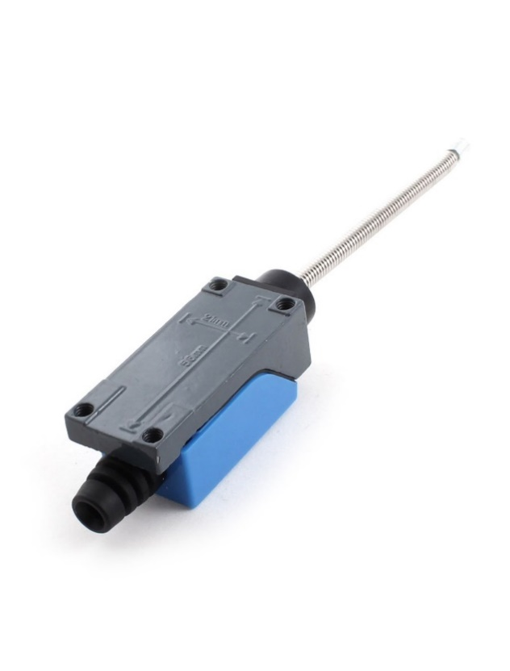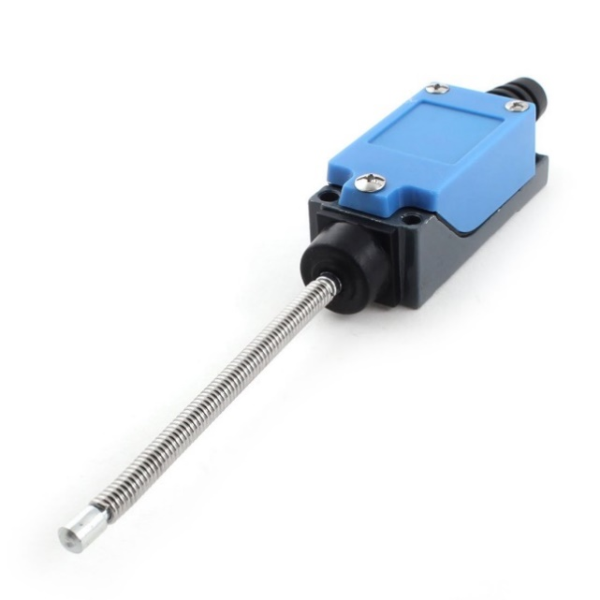

# Mounting

To keep the switch versatile, it must be easy to mount in a variety of positions and easy to fine-tune the adjustment. Like many of the open source assistive technology, we chose to include a female ½-20 UNC thread so that the switch could be mounted using camera and tripod accessories as well as most other standard assistive technology mounting solutions.

The limit switch has four threaded holes in the metal base spaced on a rectangle 21 mm x 56 mm. This bolt pattern appears to be consistent between manufacturers and different limit switch styles.

The mounting adapter was designed to utilize a ¼-20 UNC, 5/16" tee nut and the four existing mounting holes in the switch. It attaches using 4 M5x0.8 by 10 mm long machine screws. Pan head machine screws, ideally with a Phillips drive, were selected to provide a low profile and so a common screwdriver could be used instead of a hex key.

## Mounting options

* Gooseneck
* Articulating arm / Magic arm (e.g. <https://www.amazon.ca/SmallRig-Adjustable-Articulating-Monitor-Lights-2066/dp/B076KDDBW5>, $20)
* Loc-Line

# Wand Topper

The bare wire of the limit switch has a pointy end and is not safe to be used on its own. Commercial wobble switches tend to have a ball or rounded cylinder that cover the activation portion.

The initial design for the wire topper was a 4 part design, but this was too challenging to assemble.

Feedback was received on the initial proof of concept prototype that a Tee-shaped topper / handle would be useful.

A versatile feature of the wobble switch is its adaptable toppers. An anchored hex-grip base with extended threads allows for the customizability of different toppers. The T-Topper consists of five separate pieces: the socket, the top and bottom halves of the T, and two pins to hold the halves in the correct position when assembling. The socket was created to allow the female threads to be printed upwards (yielding more accurate 3D printed threads), while enabling the two T halves to be printed on the flat surface to avoid the use of support material. The same theory applies to the Ball-Topper, which only uses one pin. Printing the file vertically is the most logical orientation for the Hand-Topper, which is why the socket is combined into one file and printed as one piece.

Other attachment methods were ideated for attaching both the wand to the wire as well as between the base and the topper. Different methods were sketched, and some were prototyped such as dove tails and varying threads. Super glue was discovered to be the best option in connecting the base to the wire as the burr on the end on most units’ wire, along with inconsistent 3D printer tuning and accuracy, could not be proven to work consistently without high dexterity.

There is potential for future topper designs to be created. Depending on what is requested by an Occupational Therapist or user of the wobble switch, different toppers can be built to suit their needs, for either functionality, aesthetics, or personal interests. Figure 3 shows a variety of possible topper options.

Figure 1: Wire Attachment Ideation

Figure 2: Modular Interface Ideation

Figure 3: Wobble Switch Topper Ideation

# Testing

A preliminary proof of concept was tested with several users in an adaptive gaming setup. The wobble switch was mounted to an articulated arm and positioned near the face to provide an additional input to the Xbox Adaptive Controller.

# Version 1.1 Changes

This section will cover the changes and updates that was discussed in the previous section. The design changes focus more on improving the earlier design.

# Toppers

The original toppers were designed with a topper socket in the design which resulted in the need to print the topper pieces in half to properly mount and assemble. Example below.

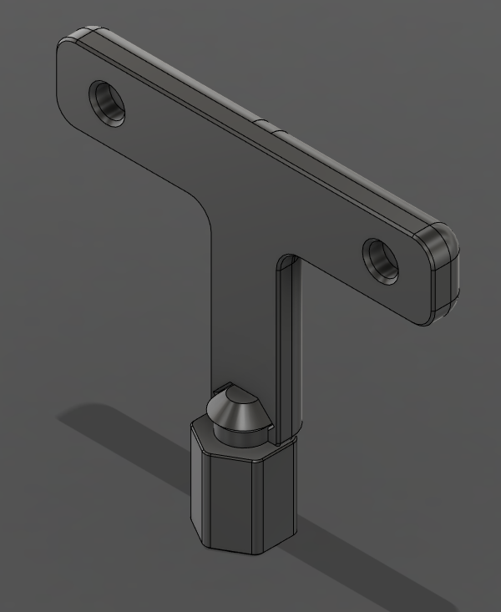

This made the assembly a little bit more complicated and required the use of glue between the two halves of the topper which, depending on the user, may not have enough glue to secure the two halves together. One idea to solve this process was to integrate a thread into the base of the topper and to print the topper as one piece. Shown below.

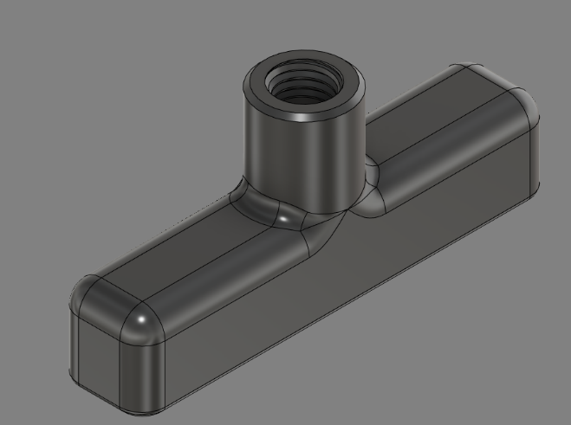

With the integrated thread we can make the topper piece shorter as well as take away the topper socket piece. This solves another issue with the original design where the weight of the topper assembly causes the switch to bend and possibly activate due to the weight of the assembly. The same concept is used for the other toppers that were designed for example, a rounded ball topper. The topper socket in the original design allows the topper piece to rotate which is undesirable but will be discussed in the next section.

# Topper Socket

The topper socket that was originally designed allows for the assembly and mounting of the topper pieces. However, with the switch having the ability to rotate, the topper socket’s original design with its own ability to rotate the top piece is no desired. Therefore, the topper socket was changed from a circular socket to a squarer or hexagonal shape to limit the amount of rotation of the topper piece. The main function of the topper socket is to allow custom pieces designed by users to be mounted onto the wobble switch.

# Male Threaded Piece

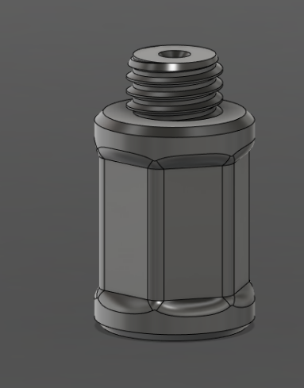

The male threaded piece shown above is the main mounting piece of the wobble switch assembly. One issue that arose when threading on the topper socket and this piece is that the hexagonal shapes may not match up and would have a sharp corner when the two pieces are threaded together. So, the top was rounded to take away the shape edge and any misalignment issues. This rounding is also done to the bottom of the piece so that it can also transition to the bottom piece.

# Bottom Transition Piece

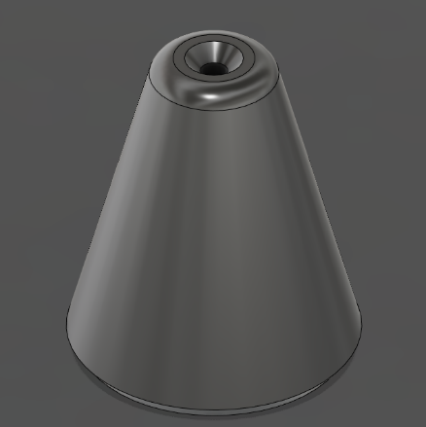

This transition piece is based off of the original Gluing jig and is mainly used as both a smoothing transition piece as well as the gluing jig for the entire assembly. This smoothens the transition between the wire and the handle pieces.